1. Brandon Kmiec, CSC 165 Section 01, A1 – Dolphin Tour
2. Screenshot of a typical sceneA video game with a black background

   Description automatically generated
3. To play the game, ride the dolphin around and visit four locations. The dolphin can be moved without riding on the back but will stop moving if it is too far away. The dolphin will be able to move again by riding on the back. Each location is a shape with a texture. Upon visiting each location, the location will disappear and a postcard magnet will appear inside of the octagon shaped bin. If the dolphin movements feels too slow, there is a power up that looks like a yellow sphere that will provide a speed boost. The game is won by visiting all four locations.
   1. Keyboard Controls:
      1. W – Move forward
      2. S – Move backward
      3. A – Yaw left
      4. D – Yaw right
      5. Up Arrow – Pitch up
      6. Down Arrow – Pitch down
      7. Spacebar – Toggle riding dolphin
      8. 2 (number row) – Enable dolphin wireframe
      9. 3 (number row) – Disable dolphin wireframe
   2. Controller Controls:
      1. Y-axis – Move forward/backward
      2. X-axis – Yaw left/right
      3. YRot-axis – Pitch up/down
      4. Button 0 – Toggle riding dolphin
      5. Button 2 – Enable dolphin wireframe
      6. Button 3 – Disable dolphin wireframe
4. My additional game activity is a power up. Located at (5, 6, -3) in the game is a yellow sphere. Upon consuming the yellow sphere, the speed of the dolphin will increase.
5. My additional game object is an octagon shaped bin located below the origin. The bin has 192 vertices and is used to hold the location postcard magnets when a location is visited.
6. My refrigerator magnets are planes with different textures. Each texture is unique to each visited location and shows the dolphin next to the location. At the start of the game, the magnets have a scale of 0.0f. Once a location is visited, the magnet associated with the location will be scaled to 0.25f and will be located inside of the octagon shaped bin below the origin.
7. Changes made to TAGE
   1. Added a method to GameObject called localPitch() to allow pitch movements for game objects
   2. Added a method to GameObject called globalYaw() to allow yaw movements for game objects
8. Requirements I wasn’t able to get working
   1. N/A
9. Additions beyond the specified requirements
   1. Added input manager mappings for keyboard inputs
   2. Additional controller and keyboard inputs through input manager
   3. Added a button action class called BttnAction for button related inputs for keyboards and controllers
   4. Added six additional custom textures
10. Assets used in the game
    1. Blackboard texture
       1. 
       2. Not made by me
       3. Obtained from <https://freestocktextures.com/texture/old-green-school-blackboard,1654.html>
       4. Creative Commons Zero License: <https://freestocktextures.com/license/>, <https://freestocktextures.com/support/>
    2. Blackboard postcard texture
       1. 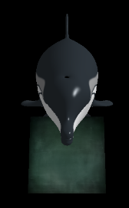
       2. Created by me using the windows Snip & Sketch tool to obtain a screenshot in the game
       3. Blackboard texture, <https://freestocktextures.com/texture/old-green-school-blackboard,1654.html>, is used in this texture. The license can be found here <https://freestocktextures.com/license/>, and mentions modifying is allowed.
       4. Dolphin texture was copied from the distributed TAGE example 01a-HelloDolphin
    3. Brick Wall texture
       1. 
       2. Not made by me
       3. Obtained from <https://freestocktextures.com/texture/texture-of-a-background-made-of-aged-bricks,1641.html>
       4. Creative Commons Zero License: <https://freestocktextures.com/license/>, <https://freestocktextures.com/support/>
    4. Brick Cube postcard texture
       1. 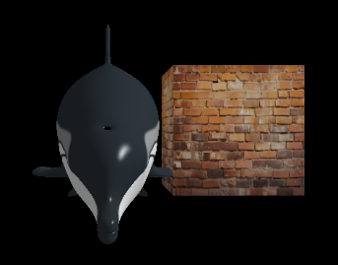
       2. Created by me using the windows Snip & Sketch tool to obtain a screenshot in the game
       3. Brick Wall texture, <https://freestocktextures.com/texture/texture-of-a-background-made-of-aged-bricks,1641.html>, is used in this texture. The license can be found here <https://freestocktextures.com/license/>, and mentions modifying is allowed.
       4. Dolphin texture was copied from the distributed TAGE example 01a-HelloDolphin
    5. Dolphin texture and dolphin wireframe texture
       1. 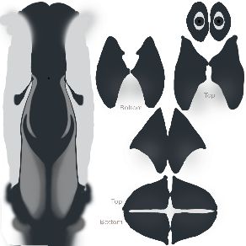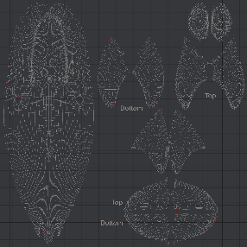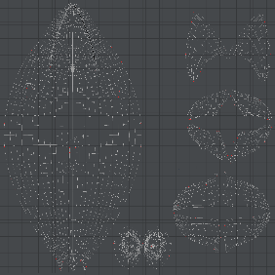
       2. Not made by me
       3. This texture was copied from the distributed TAGE example 01a-HelloDolphin
    6. Custom texture 1
       1. 
       2. Created by me using Microsoft paint
    7. Custom torus postcard texture
       1. 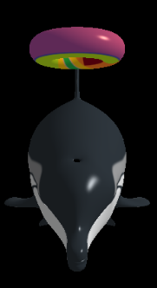
       2. Created by me using the windows Snip & Sketch tool to obtain a screenshot in the game
       3. Dolphin texture was copied from the distributed TAGE example 01a-HelloDolphin
    8. Custom texture 2
       1. 
       2. Created by me using Microsoft paint
    9. Custom sphere postcard texture
       1. 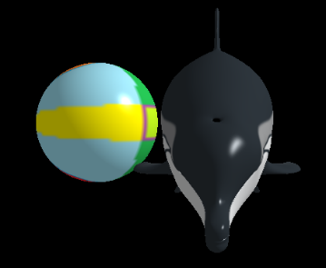
       2. Created by me using the windows Snip & Sketch tool to obtain a screenshot in the game
       3. Dolphin texture was copied from the distributed TAGE example 01a-HelloDolphin
    10. Silver texture
        1. 
        2. Created by me using Microsoft paint
    11. Sun texture
        1. 
        2. Created by me using Microsoft paint
11. Tested on RVR-5029 RAYMAN